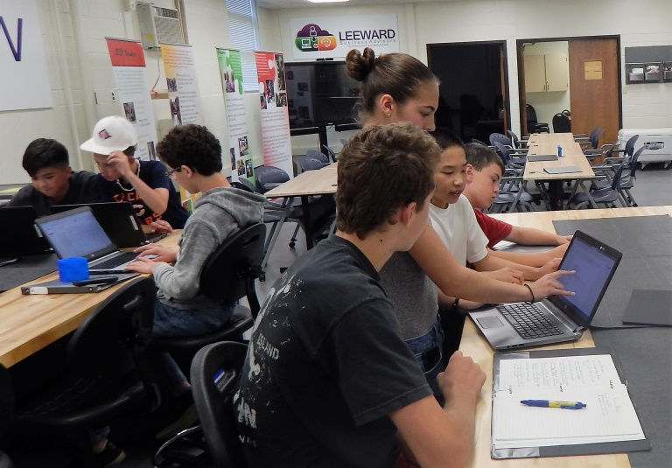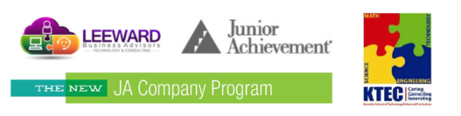

July, 2017

**“How I spent my summer vacation and $1010.00”**

Sixteen Kenosha School of Technology Enhanced Curriculum (KTEC) middle-school students didn’t get a summer job, they started their own company. Prestige Midwest is a student- run company offering a fidget-toy alternative: The Textured Cube Usable by Everyone – aka The T.-C.U.B.E.

After a two-day “boot camp,” students had decided on a product, created a 3D template using Inventor, wrote action plans, contracted a manufacture, researched sales locations and created a business plan. Prestige Midwest hosted a pitch night, inviting community members and offering stock at $10.00 a share with a 10% return. They raised $1010.00 in capital, more than doubling their goal.

Their company was created through the Junior Achievement Company Program and run in partnership with Leeward Business Advisors. This KTEC summer enrichment group meets weekly for 11 weeks in the summer. Students learn entrepreneurship concepts like capitalization, company structure, marketing, business plans, and SWOT analysis. Company meetings are student run and all aspects of the company are run by the Prestige Midwest finance, marketing, supply chain, sales, and management teams. Michael Polzin, CEO of Leeward Business Advisors and Kristen Kief, KTEC’s Community Relation Director, are there to act as advisors, but the decisions are the students.

One parent comment, “I can't believe what this group accomplished this summer. It floors me to think about these young men and women learning such important life skills. The professionalism and time management skills they learned during the summer will be extremely useful in their career. I did not have this opportunity until I was in college. It makes me very excited to see what these students can achieve within the next few years! They are very lucky to have had this opportunity.”

Production of the T.-C.U.B.E. has begun, marketing has a website and social media up and running and the sales team if finalizing the agreement to sell their product at Kenosha’s HarborMarket. Prestige Midwest invites you to tour their offices and learn more about their operations. Contact Kristen Kief to schedule a visit.

Oh, ya. Did I mention they are donating all of their profits to The Shalom Center? This was a decision they made on their own.

Kristen Kief

Kenosha School of Technology Enhanced Curriculum (KTEC)

Media and Community Relations

5710 32nd Avenue, Kenosha, WI 53144

[kkief@kusd.edu](mailto:kkief@kusd.edu)

262-359-7133

ktec.kusd.edu